Quiz 1 ***(CSE331L.7 – Asif Ahmed Neloy_Summer’20)***

Department of Electrical and Computer Engineering

School of Engineering and Physical Sciences

North South University, Bashundhara, Dhaka-1229, Bangladesh

*Time 20 minutes, Marks 20 (You need to answer all questions).*

***Name -Md.Abu saeed***

***ID -1721770642***

1. **Why it is never a good idea to store any data in the segment registers?[5]**

**Because mainly data/code store in the data segment memory, but data segment registers store data segment memory address. So, data/code store in the data segment registers is not a good idea.**

**Segment register store segment memory address so, store data in segment register is not a good idea.**

1. **Write a program in Assembly language that will add 4 integer number (1,2,2,1) using only AX register and Store the result in the AX register.**

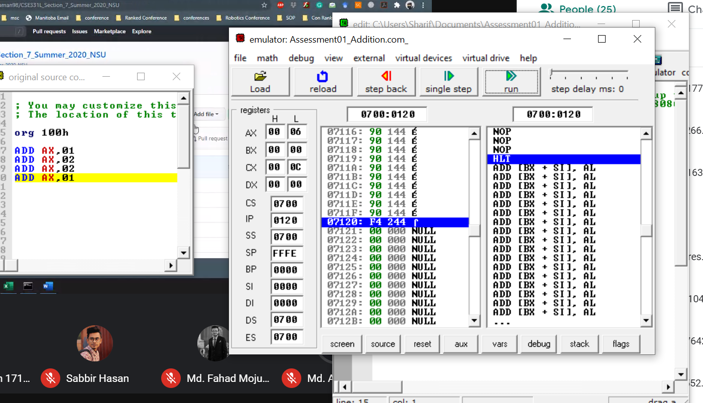

**End**